Curriculum Vitae

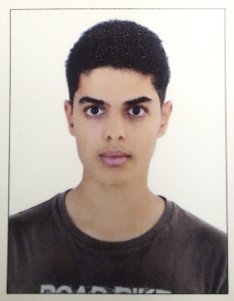

* Personal details:

Name: Omran Mohammed AL jaboori

Email: Omran20121999@gmail.com

Tel: +973 66920694

Nationality: Bahraini

Date of Birth: 4/11/1999

CPR Number: 991101375

* Education qualification:

Punctuality

Hard working

Ability to learn new things

* Certificates:

General secondary

* Experience:

Accountant in Village Gate Restaurant

Accountant in CenterPoint ((abroad in Saudi Arabia))

* Skills:

Computer and Internet proficiency

Communication

Customer Service

Problem-Solving

* Language:

Arabic (excellent)

English (good)